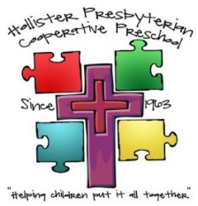

**New Family/ Student Registration Packet**

2025-2026 School Year

Lic# 350700523 523

  

**Child’s Name _______________________________________________**

**2025-2026 Class options**

**Non-Potty Trained Class**

* **2 Day Tuesday / Thursday 9:00am – 12:00pm $180/Month YOUNGER PRESCHOOL CLASS (Ages 2 -3 years old – only non-potty trained option – diapers or pull ups)**

**Standard Preschool Classes**

Class preference

Child must be potty independent for the following preschool classes:

* **2 Day Tuesday/Thursday 9:00am-12:00pm $180/Month OLDER PRESCHOOL CLASS (Ages 3 -6 fully potty trained – no diapers or pull ups allowed)**
* **3 Day Monday/Wednesday/Friday 9:00am – 12:00pm $230/Month YOUNGER PRESCHOOL CLASS (Ages 2-3.5 yrs old actively potty training – pull ups or underwear only)**
* **3 Day Monday/Wednesday/Friday 9:00am – 12:00pm $230/Month OLDER PRESCHOOL CLASS (3-6 fully potty trained no diapers or pull ups allowed)**

**Pre-K Older Age Class**

**Children eligible for Kinder Fall 2025.**

* **4 Day Tuesday/Wednesday/Thursday/Friday 9:00am – 12:00pm $355/Month (Ages 4-6, fully potty trained, underwear only)**

**Turn in completed packet along with the following for enrollment:**

* Copy of Child’s Birth Certificate – REQUIRED
* Current copy of Child’s Immunization Records – REQUIRED – we follow all state laws for required vaccines
* $180 Non Refundable Registration Fee (covers 1 child) $40 for additional children – REQUIRED at time of enrollment

**Tuition Options – Please check one (* 5 % Discount Available when paying yearly)**

* Bill Monthly
* Bill Annually*

**Children must be 2 years old at time of school commencement**

*Questions?!? Please contact the office at 630-1234 Office@HollisterPresbyterianPreschool.com*

PRESBYTERIAN CO-OPERATIVE PRESCHOOL

2066 San Benito St. Hollister, CA 95023 (831) 630-1234

REGISTRATION APPLICATION 2025-2026

|  |  |  |  |  |  |  |  |  |  |  |  |  |  |  |  |  |  |  |  |  |  |  |
| --- | --- | --- | --- | --- | --- | --- | --- | --- | --- | --- | --- | --- | --- | --- | --- | --- | --- | --- | --- | --- | --- | --- |
| Child’s Name: | | | | | | | |  | | | | | | | | | | | | | | |
| *Sex:* | Male | | | Female | | | | | Date of Birth: | | |  | | | | | | | | *Church Member Discount?* | Y | N |
| Father’s Name: | | | | | | |  | | | | | | Mother’s Name: | | | | | |  | | | |
| Address: | | |  | | | | | | | | | | Address: | |  | | | | | | | |
| Email: | |  | | | | | | | | | | | Email: |  | | | | | | | | |
| Home Phone: | | | | | |  | | | | | | | Home Phone: | | | | |  | | | | |
| Cell Phone: | | | | |  | | | | | | | | Cell Phone: | | |  | | | | | | |
| Employer: | | | | |  | | | | | | | | Employer: | | |  | | | | | | |
| Employer Address: | | | | |  | | | | | | | | Employer Address: | | |  | | | | | | |
| Work Phone: | | | | |  | | | | | | | | Work Phone: | | | |  | | | | | |
| Where does the child primarily reside: | | | | | | | | | | |  | | | | | | | | | | | |
| How Did You Hear About Us? | | | | | | | | | |  | | | | | | | | | | | | |

In addition to the individuals listed above, the following people are authorized to pick-up the child(ren) from the facility, (people who can be contacted in case you cannot be reached in an emergency). **Individuals picking up child (ren) must be over 18 years of age, with a valid driver’s license and have the necessary child safety seat.** If you need more space, use the back of this sheet.

|  |  |  |  |
| --- | --- | --- | --- |
| Name:(First & Last) | Main Contact #: | Alt. Contact #: | Relationship: |
|  |  |  |  |
|  |  |  |  |

As the parent or authorized representative, I hereby give consent to Presbyterian Co-Op Preschool to obtain all emergency medical or dental care prescribed by a duly licensed physician (M.D.) or dentist (D.D.S) for the above named child. This care may be given under whatever conditions are necessary to preserve the life, limb or well-being of the child named above.

|  |  |  |  |  |  |  |  |
| --- | --- | --- | --- | --- | --- | --- | --- |
| Dr.: |  | | Phone: |  | Medical #: |  | |
|  | |  |  |  |  | |  |
| DDS: | |  | Phone: |  | Dental Plan #: | |  |

|  |  |  |  |  |  |
| --- | --- | --- | --- | --- | --- |
| My child has the following known allergies: |  | | | | |
| The school has permission to use my child’s photo for any publicity purpose. | | | Yes | | No |
| Signature of Parent or Authorized Representative: | |  | | Date: |  |

**Co-op Agreement**

***I’ve joined a Co-op…Now what?!***

Co-op participation is a family enterprise and can be very rewarding. It creates a strong sense of community by joining families together in a common goal; drawing on each other’s talents and resources to provide a sound education environment. It provides parent education and a valuable opportunity to connect with your child. BUT – you must put in the time and energy! In a co-op, parents are the teachers, janitors, fundraisers and maintenance workers.

As a Co-op Parent I understand:

* I am making a commitment, to my child, to be a part of their education.
* I am committed to make my child’s school and class experience the best it can be.
* I am prepared to be involved; without my involvement the program will not prosper.
* I won’t find worksheets in the classroom. Instead, I will find open-ended activities and an environment that is developmentally appropriate.
* This program is designed to equip each child individually with a foundation for future learning.
* I am ready to teach, learn, play, clean, prepare food, raise funds, be around young children and get to know the other parents.
* Along with the other families in the school, I am responsible for the quality of the students’ preschool experience.

*- Parent/Guardian Initial*

As a Co-op Parent-Teacher I commit to:

* Work in the classroom one (1) to four (4) times a month.
* Know the rules of the school and consistently follow them.
* Know the rules of the classroom and consistently follow and enforce them.
* Know where things are kept in the classroom, Office and on the playground.
* Not allow my attention to be distracted from the children.
  + Not allow conversations with the other Parent-Teachers to keep me from my duties
  + Not be on my cellphone while I am a Parent-Teacher
* Give every effort to my assigned duties and area while I am a Parent-Teacher.

*- Parent/Guardian Initial*

I understand that the director and teachers will provide leadership as parents assume responsibility for program. The staff will provide parents with instruction to help increase parents’ knowledge and skills relating to children; helping to develop the parents’ abilities as educators at home and school. This agreement is subject to change upon 30 days’ notice*. My signature indicates that I have read the terms of this agreement and that I have had this material explained to me and that all of my questions have been answered satisfactorily.*

|  |  |
| --- | --- |
| Parent (Guardian) Printed Name: | Student’s Name: ____ |
| Parent (Guardian) Signature: | Date: |
| School Administrator Signature: | |

**Admission Agreement**

It is vital that all participants understand fully the requirements of the program. Please read this Admission Agreement CAREFULLY and initial each section.

**Services**

* This agreement is for basic preschool services including care and supervision within the following schedule:

1. Preschool / PreK 9am-12pm (Monday Through Friday)
2. Non- Potty Trained Preschool 9am-12pm (Tues / Thurs Only)

**Enrollment & School Policies**

* Enrollment in the school is open to the public without regard to race, religion, color, national origin or sex.
* Children must have current medical and immunization records prior to enrollment. These must be updated in compliance with state law.
* The school may terminate a child’s enrollment when it is deemed in the best interest of the child or the school. Two weeks notice will be given. If a child is deemed a physical danger to other children or staff, enrollment may be terminated immediately.
* 30 days notice in writing is required when a child is withdrawn from the School.
* I hereby give permission for my child to attend any and all onsite fun days (i.e. library bus, animal visits, community visitor demonstrations) during the regular school day by the Preschool. I understand that if I do not want my child to participate in a particular fun day, I should keep him/her home that day.
* The school is permitted to give first aid and obtain emergency medical treatment as necessary.

*____________ - Parent/Guardian Initial*

**Parents Responsibilities**

* Children must be signed in and out by a parent or an adult authorized on preschool paperwork. Adults must sign with full legal name.
* Parents or other designated persons must pick up children who become ill. Children absent due to a contagious disease may not return to the school until they are no longer contagious and with a physician’s written release.
* Parents or other designated persons must attend orientation.
* Parents or other designated persons must work in your child’s class two (2) to four (4) times a month on a rotating basis with the other class parents. Play dough will also be scheduled throughout the school year.
* Parents or other designated persons agree to complete nine (9) volunteer service hours throughout the school year.
* Parents or other designated persons must provide proof of State required immunizations (MMR, TDaP, TB and Flu).

*____________ - Parent/Guardian Initial*

**Tuition & Financial Agreements / Payment Provisions**

* Tuition is due the 1st of every month (unless special arrangements are made in advance) with no deductions for holidays or absences (school term is 9 months).
* A child’s enrollment may be terminated if the account becomes delinquent (more than 30 days past due).
* **Late payments** and **Returned checks** will incur charges based on a sliding scale. Additional specifics may be found in the Handbook.
* ***BASIC RATES:***
* ***2 Days a week T/ Th: $180 per month (includes non-potty trained class)***
* ***3 Days a week M/W/F: $230 per month***
* ***4 Days a week (PreK ): $355 per month***
* ***Enrollment fee: $180.00 per year / Siblings $40 additional fee***
* ***Project Deposit: $300.00 per year (can be waived by completing 9 project hours)***
* **We do not accept government subsidies at this time.**

* **REFUND CONDITIONS: Enrollment fee is non-refundable. Pre-paid tuition is refundable with a 30 day cancellation / drop notice. Refunds will be made via company check and will be mailed to the client’s home in a timely manner. Please allow 5-7 business days for processing.**
* **Payor: will be deemed the person signing this contract**
* **HPCP agrees to provide all child authorized representatives with 30 calendar day written notice prior to any basic rate change – all rate changes are voted on and approved by the board on a yearly basis**

*____________ - Parent/Guardian Initial*

***The Department or Licensing Agency shall have the authority to interview children, staff, and to inspect and audit child or facility records without prior consent. The licensee shall make provisions for private interviews with any children or staff members, and for the examination of all records relating to the operation of the child care center. The Department has the authority to observe the physical condition of the child(ren), including conditions that could indicate abuse, neglect or inappropriate placement.***

I agree to cooperate with the general policies of the school, to perform the obligations of parents or guardians as set forth in this Agreement, and to abide by the rules, regulations, and manuals provided by the school. **I agree to the right of the department to perform the duties as stated in the sections above**. This agreement is subject to change upon 30 days’ notice*. My signature indicates that I have read the terms of this agreement and that I have had this material explained to me and that all of my questions have been satisfactorily answered. I also understand I am responsible for ALL information in the Preschool Handbook*

|  |  |  |  |  |  |  |  |
| --- | --- | --- | --- | --- | --- | --- | --- |
| Parent (Guardian) Printed Name: | | |  |  | Student’s Name: | |  |
| Parent (Guardian) Signature: |  | | |  | Date: |  | |
| School Administrator Signature: | |  | |

## Committee Preference Form

Child’s Name: ______________________________ Parents’ Names: _____________________________

Rank the following in order of preference. No previous experience is required for most positions.

Positions below will fulfill project hours.

**Executive Board**

**The President:** Works with the Director to co-ordinate the activities of the school, help with enrollment, preside at all meetings, serve as Chairperson of the Nominating Committee, provides support for the Tour Coordinator and be an ex-officio member of all committees and attends monthly Board Meetings.

**Vice President**: Presides in the absence of the President, maintains health records and children’s files in compliance with state Licensing law, maintains student immunization records, meets with committee members in July and August to prepare for start of school year and attends monthly Board Meetings.

**Special Assignments: Circle any positions you may be interested in filling within this committee.**

* **Immunization Reporting -** Works with VP to complete immunization reporting required by licensing including filing student enrollment records, follow-up with parents and completion of a detailed, time- sensitive on-line report.

**Secretary:** Takes minutes at all meetings and is in charge of all school correspondences.

**Treasurer:** (R*equires 1 year experience at HPCP):* Keeps accurate records of accounts; have a familiarity with Excel, organization skills, detail oriented. Attends monthly Board Meetings and serves as a Chairperson on the Budget Committee.

**Fundraising:** Responsible to organize events to raise money as directed by the Board, helps with the coordination of school fundraisers (pie, pasta, candy, and flowers), assists with the fundraising efforts within each class and attends monthly Board Meetings.

**Special Assignments: Circle any positions you may be interested in filling within this committee.**

**Events**: Works together as a team to plan and execute 3 events; Orientation, Mid-Year Open House and Staff/Board Appreciation Dinner. Meets with committee as needed before special events and attends monthly Board Meetings.

**Publicity:** Chairperson must have enthusiasm for our preschool program and want to share it. Will assist with the overall publicity and marketing of the school. Being web savvy and graphic design experience are helpful. Meets with committee once in August and twice before Open House and attends monthly Board Meetings.

* **Signage/Advertising Coordinator:** Set-up and manage of school signs and assist with Events to advertise Registration, Open House and Appreciation Dinner. Graphic Design is helpful.

**Maintenance** (Co-Chairs): Works with the Buildings and Grounds Chairperson(s) of the Church, and shall be responsible for organizing the cleaning and maintenance of the Preschool classrooms and grounds.

Maintenance Chairs will manage/direct one Saturday maintenance day. Implement and maintain all safety procedures and emergency preparedness within the school.. Members on this committee are responsible for special projects, as needed, and the school’s overall maintenance and cleaning. Members must attend an orientation in July. 2 year term limit.

Please circle any maintenance skills you feel comfortable doing.

|  |  |  |  |
| --- | --- | --- | --- |
| Carpentry | Toy Repair | Welding | Horticulture |
| Plumbing | Yard Maintenance | Carpet Laying | Painting |
| Masonry | Tile Work | Cement Work | Web Design |
| Graphic Design | Event Planning | Sewing | Grant Writing |
| Scrapbooking | Photography | Blogging |  |
| Other, please specify | | | |

Please circle any maintenance tools you have and are willing to bring to a workday.

|  |  |  |  |  |  |
| --- | --- | --- | --- | --- | --- |
| Power tools | Extension cord | Paint Brushes | Tree trimmers | Shovel | Welding equipment |
| Wheelbarrow | Ladder | Truck/Trailer | Rototiller | Rake | Leaf Blower /Vacuum |
| Other, please specify | | | | | |
| If you are able to purchase any goods or services for the school at a reduced rate, please describe: | | | | | |

**Project Deposit Requirements**

* Requires 9 volunteer hours per year/per family
* 3 hours must be completed per Trimester (Sept-Nov, Dec-Feb, and Mar-May)
* If 3 hours are not completed in a trimester 1/3 of the deposit will be billed ($75)
* A family cannot complete all 9 hours in 1 single trimester
* Only 3 hours may be completed per trimester unless otherwise agreed to by Director for larger projects

## Mandatory Pertussis, Measles and Influenza Vaccines

The **Mandatory** Vaccines must be completed and returned for **every** person who will work in the classroom for your child (***parents, grandparents, other relatives, or friends***).

###### All Volunteers must turn in ONE of the following:

* A copy of immunization record for Influenza (or waiver), Pertussis, TB and MMR OR
* A stamped and signed statement from a physician that there is a medical reason to NOT vaccinate OR
* A stamped and signed statement from a physician that the volunteer is already immune to influenza, pertussis and MMR

Vaccines for Child Care Volunteers

|  |  |
| --- | --- |
| Adult’s Name: ___________________ | Child’s Name: ___________________ |
|  |  |

Vaccines:

Influenza Pertussis MMR

TB Test: Negative skin test reaction within four years

* Proof of titer blood tests are accepted
* Yellow vaccine record or stamped and signed doctors / clinic print out required
* Only the Flu vaccine can be waived (see next page in packet)

**Hollister Presbyterian Co-Op Preschool**

Flu Vaccine Waiver

# Hollister Presbyterian Co-Op Preschool is a parent participation school. Both our Licensing and the Health Department require all volunteers have proof of immunization to MMR, Pertussis, and annual Flu virus.

Parents may refuse the annual Flu vaccine by signing the following statement:

Parent’s Name: Childs Name:

I have discussed the annual Influenza vaccine with my health care provider and decline the Flu vaccine for the 2025-2026 flu season.

Date:

Parent Signature:

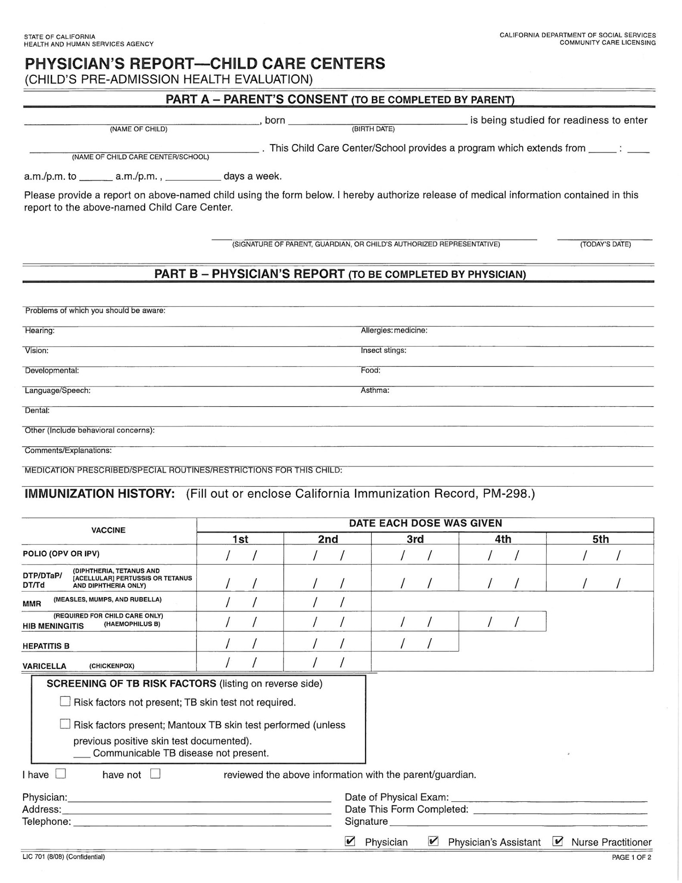

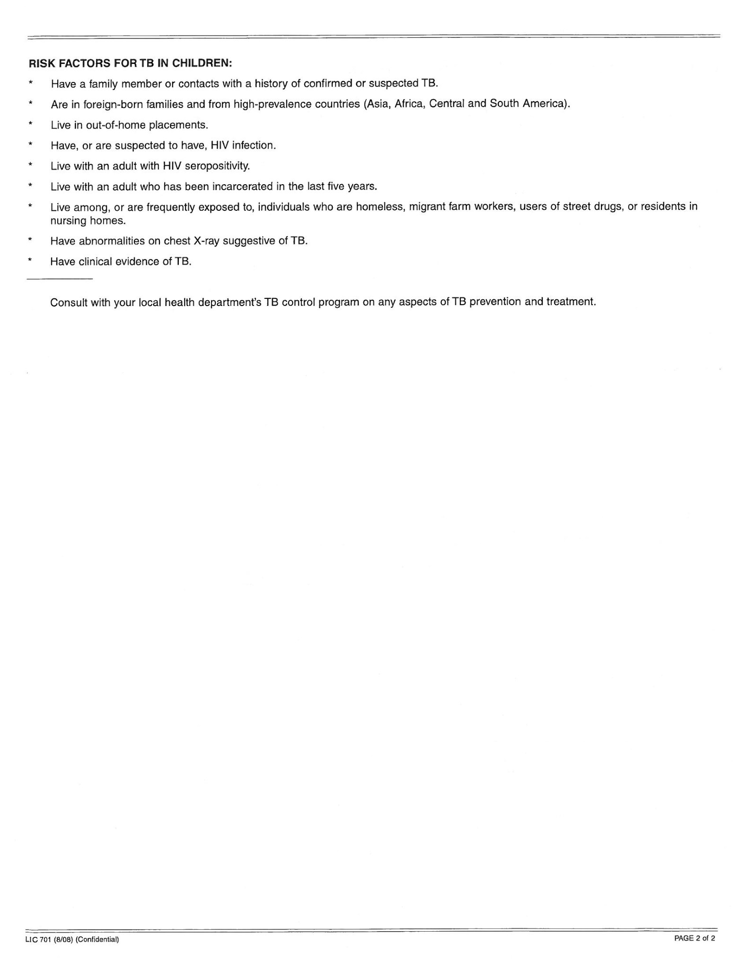

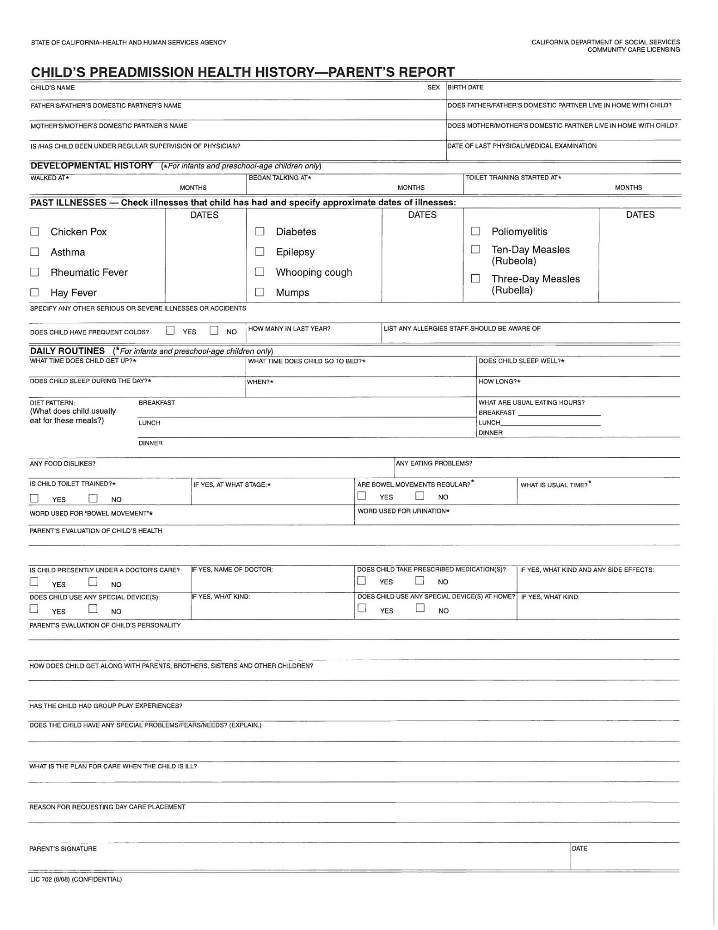**SAN BENITO COUNTY PUBLIC HEALTH SERVICES DISCLOSURE TO PATIENT OR PARENT/GUARDIAN ON IMMUNIZATION RECORD SHARING WITH REGISTRIES**

(Prepared pursuant to Health and Safely Code Section 120440)

This school will share some information on your child with the local public health department immunization registry and the state health department, unless you refuse to allow this. The registry may share this information with doctors, clinics or hospitals your child goes to for care, if they ask for it. The only information we will share is:

Your name and your child’s name, your child’s date of birth, your child’s birthplace, vaccines he or she has received, any serious reaction he or she had to a vaccine, your address and phone number, and other non- medical information if needed to make sure it is the correct person's record.

The doctors, clinics or hospitals which get this information can use it only to:

* Help in deciding what vaccines your child needs;
* Phone or send you a reminder when a vaccine is due; and
* Tally numbers of patients who are or are not up-to-date on their vaccines

The registry may also share this information with the following, if they request it: schools, child care centers, WIC supplemental food clinics, the Cal Works public assistance program, health care plans, and other persons or entities when disclosure is otherwise specifically authorized by law. These persons and entities can use that information **only** for the reasons listed above, and (a) for schools or child care centers, to help you prove your child has had the vaccines required for entry, (b) for WIC clinics, to let you know if you child has vaccine doses due, and (c) for the health care plans, to help process insurance payments.

All of these people and groups listed above who ask for and get this information are required by law to keep it confidential and use it only for the reasons listed above. Also, you have the rights listed below:

* To refuse to have us share any of this information now or at any time.
* To refuse to get reminder notices when vaccines are due.
* To look at your child's record at the health department registry and correct any errors.
* To get names and addresses of anyone with whom this information is shared.

Please complete the bottom section of this form indicating your preference regarding sharing your child’s immunization records. Please initial next to the statement(s) that reflect your preferences.

|  |  |
| --- | --- |
| Child’s Name: | Date of Birth: |
| Address: | Phone: |
| Signature of  Parent/Guardian | Date: |

I *agree* to allow the sharing of the information described above regarding this child’s immunization

record with the Public Health Department Immunization Registry or State Department of Health

Initials

Services. This reverses any previous refusals to allow sharing.

I **DO NOT** want this school to share the information described above regarding this child’s

immunization records with the Public Health Department Immunization Registry or State

Initials

Department of Health Services.

**Hollister Presbyterian Co-Operative Preschool**

*"Helping children put it all together"*

2066 San Benito Street • Hollister, CA 95023

Phone/Fax: 831-630-1234 • www.hollisterpresbyterianpreschool.com

E-mail: office@hollisterpresbyterianpreschool.com

Facebook: Hollister Presbyterian Co-op Preschool

**PHOTO/MEDIA RELEASE AUTHORIZATION**

**OPTION 1:**

**FULL PUBLIC MEDIA RELEASE**

By signing below, I irrevocably grant permission to Hollister Presbyterian Co-operative Preschool and its employees, agents, partners and advertisers, to record and use my child’s, image, statements and/or art work including any and all photographic/still images and video or audio recordings made by Hollister Presbyterian Preschool and its assignee(s), advertisers, customers, agents and successors for unrestricted use in print and electronic mediums including but not limited to publications, displays, websites, social media, advertisements, recruitment and publicity/promotions/campaigns, without notifying me. I voluntarily waive any right to inspect/approve the finished photographs/likenesses, writings or electronic matter that may be used in conjunction with them now or in the future, whether that use is known or unknown to me. I also waive any right to royalties or any other compensation arising from or related to the use of the photograph(s) or other media.

I understand that this release constitutes a waiver of my privacy rights under The Federal Educational Rights and Privacy Act (FERPA).

**I am the parent/legal guardian for the minor child listed below, and I am competent to sign this release. I have read the release before signing below, and I fully understand the contents, meaning and impact of this release. I understand that I am free to address any specific questions regarding this release by contacting Wendy Shepherd / Director and I agree that my failure to do so will be interpreted as a free and knowledgeable acceptance of the terms of this release.**

Child’s Full Name: _______________________________

Signature Parent/Legal Guardian Signature: __________________________

Print Full Name Print Full Name/Relationship: ___________________________

Date: __________________

Email Address and Phone Number: __________________________________________

**OPTION 2:**

I CONSENT TO MY CHILD’S PHOTOS AND VIDEOS BEING SHARED ON THE ***PRIVATE CLASS FACEBOOK PAGE ONLY.*** THIS PAGE IS FOR CLASS FAMILIES ONLY AND IS A CLOSED PRIVATE PAGE MANAGED BY YOUR CHILD’S TEACHER.

Signature: _____________________________ Date: __________________________

**OPTION 3:** **DECLINE ALL MEDIA**. I understand that I will not be able to view any photos of my child’s school day.

Signature: ____________________________ Date:_____________________________

**HOLLISTER PRESBYTERIAN PRESCHOOL COVID -19 / ILLNESS /INJURY WAIVER OF LIABILITY AND HOLD HARMLESS AGREEMENT**

In consideration for enrollment at HOLLISTER PRESBYTERIAN PRESCHOOL I, on behalf of myself and any minor child/children for whom I have the capacity to contract, hereby acknowledge and agree to the following:

1. I understand the hazards of the novel coronavirus (“COVID-19”) and am familiar with the Centers for Disease Control and Prevention (“CDC”) guidelines regarding COVID-19. I acknowledge and understand that that the circumstances regarding COVID-19 are changing from day to day and that, accordingly, the CDC guidelines are regularly modified and updated and I accept full responsibility for familiarizing myself with the most recent updates. I also, understand the hazards of contagious illness not limited to COVID 19. I understand that accidents at school leading to injuries may occur and am aware of the risk.

2. Notwithstanding the risks associated with COVID-19, the flu and any other contagious illness as well as injury which I readily acknowledge, I hereby willingly choose to ENROLL MY CHILD IN HOLLISTER PRESBYTERIAN PRESCHOOL.

3. I acknowledge and fully assume the risk of illness or death related to COVID-19, other contagious illnesses & injuries arising from my being on the premises and participating in PRESCHOOL and hereby RELEASE, WAIVE, DISCHARGE, AND COVENANT NOT TO SUE (on behalf of myself and any minor children form whom I have the capacity contract) HOLLISTER PRESBYTERIAN PRESCHOOL and / or CHRIST FELLOWSHIP CHURCH their owners, officers, directors, agents, employees and assigns (the “RELEASEES”) from any liability related to illness or injury which might occur as a result myself or my child(Ren) being on the premises and participating in preschool.

4. I shall indemnify, defend and hold harmless the RELEASEES from and against any and all claims, demands, suits, judgments, losses or expenses of any nature whatsoever (including, without limitation, attorneys’ fees, costs and disbursements, whether of in-house or outside counsel and whether or not an action is brought, on appeal or otherwise), arising from or out of, or relating to, directly or indirectly, the infection of COVID-19 or any other illness or injury.

5. It is my express intent that this Waiver and Hold Harmless Agreement shall bind any assigns and representatives, and shall be deemed as a RELEASE, WAIVER, and DISCHARGE AND COVENANT NOT TO SUE the above-named RELEASEES. This Agreement and the provisions contained herein shall be construed, interpreted and controlled according to the laws of the State of California. I HEREBY KNOWINGLY AND VOLUNTARILY WAIVE ANY RIGHT TO A JURY TRIAL OF ANY DISPUTE ARISING IN CONNECTION WITH THIS AGREEMENT. I ACKNOWLEDGE THAT THIS WAIVER WAS EXPRESSLY NEGOTIATED AND IS A MATERIAL INDUCEMENT THE PERMISSION GRANTED BY RELEASEES TO BE ON PREMISES AND PARTICIPATE IN PRESCHOOL ACTIVITIES.

IN SIGNING THIS AGREEMENT, I ACKNOWLEDGE AND REPRESENT THAT I have read the foregoing Wavier of Liability and Hold Harmless Agreement, understand it and sign it voluntarily as my own free act and deed; no oral representations, statements, or inducements, apart from the foregoing written agreement, have been made; I am at least eighteen (18) years of age and fully competent; and I execute this Agreement for full, adequate and complete consideration fully intending to be bound by same.

I have signed this Waiver and Agreement on this _____________________________ day of _______________________, 20_______.

NAME / SIGNATURE: _______________________________________________

NAME(S) OF MINOR CHILD (REN): ______________________________________________________________________________

HPCP EXECUTIVE DIRECTOR SIGNATURE: ______________________________

**Presbyterian Co-operative Preschool**

2066 San Benito Street, Hollister, CA 95023

Phone: 831-630-1234 Fax: 831-630-1234

Website: hollisterpresbyterianpreschool.com

Email: office@hollisterpresbyterianpreschool.com

CONFIDENTIALITY AGREEMENT

I __________________________________ understand that as a member of the Presbyterian Cooperative Preschool I may have access to confidential information. As an enrolled parent, I undertake:

1. to take all possible steps to preserve strict confidentiality regarding any information to which I have access through my serving in the classroom
2. never to pass any information obtained to anyone outside of the staff, unless I have been directed to do so by the Director, or a member of staff, and the reasons for doing so are clearly understood.
3. agrees that he or she will at no time, during or after enrollment, use for his or her own benefit or the benefit of others, or disclose or divulge to others, any such confidential information.
4. to keep all names, contact details and personal information secure.
5. never to disclose how another child’s day was or to discuss another child’s progress to anyone other than staff
6. never to post photos on personal social media other than of my own child – class pages are for photo sharing only

I understand that any breach of the above will result in disciplinary action and/or may expose me to a suit for damages in a court of law.

Signed____________________________________ Date______________________________

STATE OF CALIFORNIA·HEALTH ANO HUMAN SERVICES AGENCY CALIFORNIA DEPARTMENT OF SOCIAL SERVICES

##### PERSONAL RIGHTS

**Child Care Centers**

Personal Rights, See Section 101223 for waiver conditions applicable to Child Care Centers.

1. Child Care Centers. Each child receiving services from a Child Care Center shall have rights which include, but are not limited to, the following:
   1. To be accorded dignity in his/her personal relationships with staff and other persons.
   2. To be accorded safe, healthful and comfortable accommodations, furnishings and equipment to meet his/her needs.
   3. To be free from corporal or unusual punishment, infliction of pain, humiliation, intimidation , ridicule, coercion, threat, mental abuse, or other actions of a punitive nature, including but not limited to: interference with daily living functions, including eating, sleeping, or toileting; or withholding of shelter, clothing, medication or aids to physical functioning.
   4. To be informed, and to have his/her authorized representative, if any, informed by the licensee of the provisions of law regarding complaints including, but not limited to, the address and telephone number of the complaint receiving unit of the licensing agency and of information regarding confidentiality.
   5. To be free to attend religious services or activities of his/her choice and to have visits from the spiritual advisor of his/her choice. Attendance at religious services, either in or outside the facility, shall be on a completely voluntary basis. In Child Care Centers, decisions concerning attendance at religious services or visits from spiritual advisors shall be made by the parent(s), or guardian(s) of the child.
   6. Not to be locked in any room, building, or facility premises by day or night.
   7. Not to be placed in any restraining device, except a supportive restraint approved in advance by the licensing agency.

THE REPRESENTATIVE/PARENT/GUARDIAN HAS THE RIGHT TO BE INFORMED OF THE APPROPRIATE LICENSING AGENCY TO CONTACT REGARDING COMPLAINTS, WHICH IS:

|  |  |  |
| --- | --- | --- |
| NAME  Department of Social Services |  | |
| ADDRESS |  |  |
| 2580 N. First St. Suite 300, MS 29-08 |  |  |
| CITY  San Jose, Ca. | ZIP CODE  95131 | AREA CODE/TELEPHONE NUMBER  408-324-2148 |

DETACH HERE

**TO: PARENT/GUARDIAN/CHILD OR AUTHORIZED REPRESENTATIVE: PLACE IN CHILD'S FILE**

Upon satisfactory and full disclosure of the personal rights as explained, complete the following acknowledgment:

**ACKNOWLEDGMENT:** I/We have been personally advised of, and have received a copy of the personal rights contained in the California Code of Regulations,Title 22, at the time of admission to:

(PRINT THE NAME OF THE FACILITY)

Hollister Presbyterian Co-Op Preschool

(PRINT THE NAME OF THECHILD)

(SIGNATURE OF THE REPRESENTATIVE/PARENT/GUARDIAN)

I (PRINTTHE ADDRESS OF THE FACILITY)

1 2066 San Benito St. Hollister, Ca. 95023

(TITLE OF THE REPRESENTATIVE/PARENT/GUARDIAN)

(DATE)

LIC 613A (8/08)

STATE OF CALIFORNIA-HEALTH AND HUMAN SERVICES AGENCY CAL FORNIA DEPARTMENT OF SOCIAL SERVICES COMMUNITY CARE LICENSING DIVIS ON

CHILD CARE CENTER NOTIFICATION OF PARENTS' RIGHTS

**PARENTS ' RIGHTS**

As a Parent/Authorized Representative, you have the right to:

1. Enter and inspect the child care center without advance notice whenever children are in care.
2. File a complaint against the licensee with the licensing office and review the licensee's public file kept by the licensing office.
3. Review, at the child care center, reports of licensing visits and substantiated complaints against the licensee made during the last three years.
4. Complain to the licensing office and inspect the child care center without discrimination or retaliation against you or your child.
5. Request in writing that a parent not be allowed to visit your child or take your child from the child care center, provided you have shown a certified copy of a court order.
6. Receive from the licensee the name, address and telephone number of the local licensing office. Licensing Office Name: Department of Social Services Licensing Office Address: 2580 N. First St. Suite 300, MS 29-08, San Jose, Ca.95131 Licensing Office Telephone #: 408-324-2148
7. Be informed by the licensee, upon request, of the name and type of association to the child care center for any adult who has been granted a criminal record exemption, and that the name of the person may also be obtained by contacting the local licensing office.
8. Receive, from the licensee, the Caregiver Background Check Process form.

*NOTE: CALIFORNIA STATE LAW PROVIDES THAT THE LICENSEE MAY DENY ACCESS TO THE CHILD CARE CENTER TO A PARENT/AUTHORIZED REPRESENTATIVE IF THE BEHAVIOR OF THE PARENT/AUTHORIZED REPRESENTATIVE POSES A RISK TO CHILDREN IN CARE.*

*For the Department of Justice "Registered Sex Offender"database,go to* [*www.meganslaw.ca.*](http://www.meganslaw.ca/)*gov*

___________________Lic 995 (9/08)___________ _____________________(Detach Here – Give upper portion to Parents________________________

_ _ _ _ _ _ _ _ _ _ _ _ _ _ _ _ _ __ _ _ _ _ _ _ _ _ _ _ _ _ _ _ _ _ __ _ _ _ _ _ _ _ _ _ _ _ _ _ _ _ _ __ _ _ _ _ _ _ _ _ _ _ _ _ _ _ _ _ _ _ _ _ _ _ _ _ _ _ _ _ _ _ _ _ _ _ _

A C K NOW L E DG E M E NT O F NOT IF IC AT IO N O F PA R E NTS ' R IG HT S

*(Parent/Authorized Representative Signature Required)*

I, the parent/authorized representative of , have

received a copy of the "CHILD CARE CENTER NOTIFICATION OF PARENTS' RIGHTS" and the CAREGIVER BACKGROUND CHECK PROCESS form from the licensee.

Hollister Presbyterian Co-Op Preschool

Name of Child Care Center

Signature (Parent/Authorized Representative)

Date

*NOTE: This Acknowledgement must be kept in child's file and a copy of the Notification given to parent/authorized representative.*

*For the Department of Justice "Registered Sex Offender"database go to* [*www.meganslaw. ca.gov*](http://www.meganslaw.ca.gov/)

LIC 995 (9/08



**Presbyterian Co-operative Preschool**

**2025-2026 Stay & Play Program Interest** Presbyterian Co-op Preschool would like to offer *after-school enrichment* with our own wonderful teachers.

Days: Tuesday, Wednesday and Thursday (Excluding Holidays and School vacations). Child may attend with concurrent enrollment days. **POTTY INDEPENDENT CHILDREN ONLY- NO DIAPERS, PULL UPS OR FREQUENT ACCIDENTS**

Hours: 12 pm – 1:50 pm (children must be picked up by 1:50 pm to avoid late fees and possible drop from the Stay and Play program)

Additional Cost Added to Tuition:

* 1 Day $55 per child (monthly)
* 2 Day $100 per child (monthly)
* 3 Day $145 per child (monthly)
* Siblings discounted by $10 monthly

Requirements:

* Child is currently registered in the Presbyterian Preschool on days offered
* Child brings their own NUT FREE lunch

********************************************************************************************

I would be interested in afternoon program for my child(ren).

_____________________________

Child /rens Name(s)\

____Tuesday ____Wednesday ____Thursday

********************************************************************************************

**THIS IS AN INTEREST FORM ONLY. STAY AND PLAY IS TBD.**